Data Analysis Executive Summary Report Format
Remove generic titles & footer. Replace section headings with Wordart. Add fancy borders. Strategically place meaningful pictures throughout these first five to six pages to fill unused space.

(REPORT TITLE – Your Choice)
Purpose & Scope: The State of California requires all public schools to assess their students’ physical fitness through a series of tests known as “The Fitnessgram”. According to the California Physical Education Fitness Test Reference Guide:
“The Fitnessgram is a comprehensive, health-related physical fitness battery developed by the Cooper Institute. . . . The Fitnessgram is designed to assess six key fitness areas that represent three broad components of fitness: (1) aerobic capacity, (2) body composition, and (3) muscle strength, endurance and flexibility. . . . The desired performance standard for each fitness-area test is the Healthy Fitness Zone (HFZ).”
A student is considered to have met the Fitnessgram standards if they score in the HFZ in five out of the six fitness tests. Non-passing scores consist of “Needs Improvement” (NI) and “Needs Improvement – High Risk” (NI – High Risk).
Granada Hills Charter High School (GHCHS) implements the Fitnessgram in all of its physical education (PE) classes. Since only two years of PE is required to graduate, most PE students are sophomores and freshmen. Our analyses of this fitness test data seek to address three key questions.
What were the performance norms for GHCHS students in the April 2012 testing?
What proportion of students passed the six individual tests, and how many students met the overall performance standard of passing five of the six fitness components?
Are any patterns present in the data that demonstrate areas where students struggle to meet the Fitnessgram standards?

Our Team: (#) students investigated this proposition.
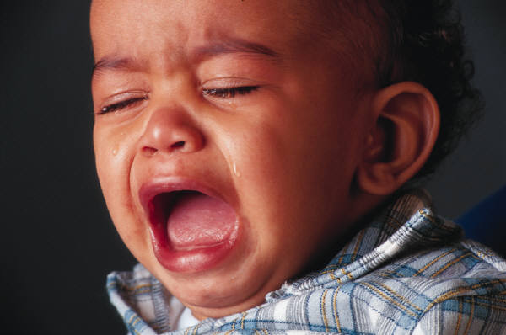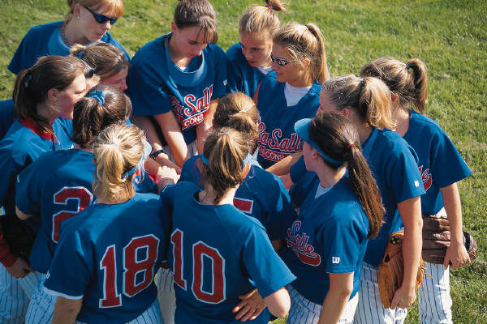

USE SILLY NAMES, & PICTURES BUT INCLUDE YOUR REAL STUDENT IDs (NO REAL NAMES)

Methods: In April 2012, the Physical Education (PE) department of Granada Hills Charter High School (GHCHS) tested 859 students in five areas of physical fitness: the mile run, shoulder stretches, trunk lifts, push-ups, and pull-ups. In addition, each student’s height and weight were recorded to determine their Body Mass Index (BMI). This test data was assembled in an Excel spreadsheet, and provided to our student teams by Janie Holm, GHCHS’s testing coordinator.
Our team used Excel’s data analysis functions and graphic displays to examine student performance for each fitness variable. In an addendum to this report, we have statistically described the distribution for each variable. These descriptions consider the population of all physical education students, as well as the male and female subpopulations. Comparison charts focus on the differences in the performance of the male and female students. An analysis of correlations examined if any associations existed between performance results.

Summary of Findings:
#1: What were the performance norms for GHCHS students in the April 2012 testing?
A series of parallel boxplots follow that visually summarize and compare key distribution features for the male and female subpopulations.
INSERT SIX PAGES OF BOXPLOTS HERE
Write a few sentences after each parallel boxplot to summarize these displays. A list might summarize differences in the centers for males and females, compare the spread of male and female performance, and identify any significant differences in the number of outliers for the two populations (how many outliers were from males vs. females).

#2: What proportion of students scored in the Healthy Fitness Zone for each of the six Fitnessgram tests, and how many students met the performance standard in at least five of the six fitness components?
A segmented bar chart addresses the first part of this question. It shows the proportion of students who scored in the Healthy Fitness Zone in each of the six physical fitness tests. Next a bar chart illustrates the number of tests that each student passed with a HFC score.
INSERT PAGE WITH THE TWO GRAPHIC DISPLAYS HERE

#3: Are any patterns present in the data that suggest areas where students struggle to meet the Fitnessgram standards?
WRITE TWO TO THREE PARAGRAPHS HERE TO ADDRESS QUESTION

Detailed Findings: The addendum of detailed findings have been organized as follows:

Description of Distributions For Entire Population:
Mile Time in the population of GHCHS PE students . . . . . . . . . . . . . . . . . . . . . . . . . .7
(Variable) in the population of (Identify specific population) . . . . . . . . . . . . . . . .8
(Variable) in the population of (Identify specific population) . . . . . . . . . . . . . . . .9
(Variable) in the population of (Identify specific population) . . . . . . . . . . . . . . 10
(Variable) in the population of (Identify specific population) . . . . . . . . . . . . . . 11

Description of Distributions For Female Population:
(Variable) in the population of (Identify specific population) . . . . . . . . . . . . . . 12
(Variable) in the population of (Identify specific population) . . . . . . . . . . . . . . 13
(Variable) in the population of (Identify specific population) . . . . . . . . . . . . . . 14
(Variable) in the population of (Identify specific population) . . . . . . . . . . . . . . 15
(Variable) in the population of (Identify specific population) . . . . . . . . . . . . . . 16

Description of Distributions For Entire Population:
(Variable) in the population of (Identify specific population) . . . . . . . . . . . . . . 17
(Variable) in the population of (Identify specific population) . . . . . . . . . . . . . . 18
(Variable) in the population of (Identify specific population) . . . . . . . . . . . . . . 19
(Variable) in the population of (Identify specific population) . . . . . . . . . . . . . . 20
(Variable) in the population of (Identify specific population) . . . . . . . . . . . . . . 21

Comparison of Distributions:
Table A. compares distribution of (Variable) for the subpopulations
of (Identify specific populations) . . . . . . . . . . . . . . . . . . . . . . . . . . . . . . . . . . . . . . . . . 22

Table B. compares distribution of (Variable) for the subpopulations
of (Identify specific populations) . . . . . . . . . . . . . . . . . . . . . . . . . . . . . . . . . . . . . . . . . 23

Table C. compares distribution of (Variable) for the subpopulations
of (Identify specific populations) . . . . . . . . . . . . . . . . . . . . . . . . . . . . . . . . . . . . . . . . . 24

Table D. compares distribution of (Variable) for the subpopulations
of (Identify specific populations) . . . . . . . . . . . . . . . . . . . . . . . . . . . . . . . . . . . . . . . . . 25

Table E. compares distribution of (Variable) for the subpopulations
of (Identify specific populations) . . . . . . . . . . . . . . . . . . . . . . . . . . . . . . . . . . . . . . . . . 26

Pie Chart F. compares distribution of (Variable) for the subpopulations
of (Identify specific populations) . . . . . . . . . . . . . . . . . . . . . . . . . . . . . . . . . . . . . . . . . 27

Pie Chart G. compares distribution of (Variable) for the subpopulations
of (Identify specific populations) . . . . . . . . . . . . . . . . . . . . . . . . . . . . . . . . . . . . . . . . . 28

